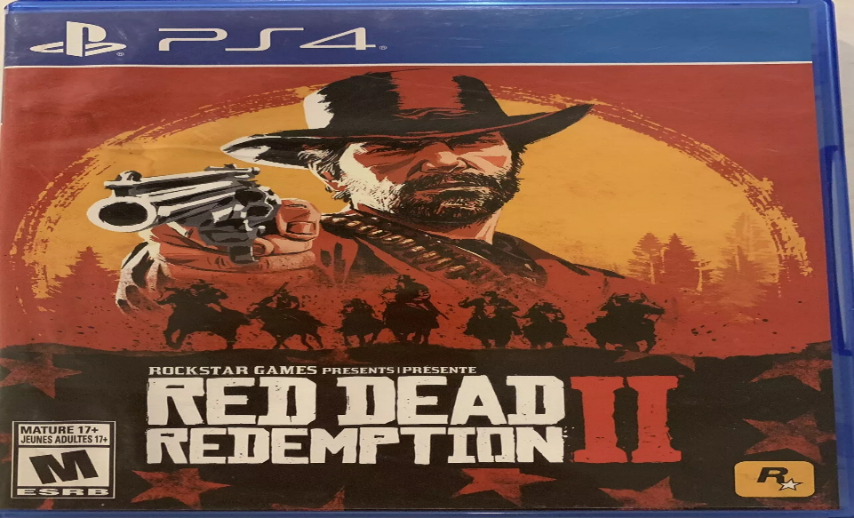

**Red Dead Redemption 2:**

1️.**Immersive Storyline & Characters**

* Play as **Arthur Morgan**, an outlaw struggling between loyalty to his gang and his own personal morals.
* Rich character development with dynamic relationships and choices affecting the story.
* Features iconic characters like **Dutch van der Linde, John Marston, and Sadie Adler**.

2️. **Massive Open World**

* Explore a highly detailed world with towns, forests, mountains, rivers, and swamps.
* Dynamic weather, wildlife, and day-night cycles enhance realism.
* NPCs remember your actions, react to your behavior, and create a living world.

3️. **Realistic Gameplay & Mechanics**

* **Honor System** – Choices impact Arthur’s reputation and how the world perceives him.
* **Survival Elements** – Eat, sleep, and maintain weapons and horses.
* **Customizable Experience** – Outfits, weapons, and even Arthur’s beard grow in real time!

4️. **Red Dead Online (Multiplayer Mode)**

* Launched on **November 27, 2018**.
* Allows players to create their own outlaw, form gangs, and explore the frontier.
* Features story missions, bounty hunting, trade, and PvP/PvE activities.

5️. **Stunning Visuals & Realism**

* One of the most visually impressive games ever made.
* Highly detailed animations, realistic horse mechanics, and breathtaking landscapes.
* Deep AI interactions where NPCs have unique routines and remember player actions.